**MACHINE LEARNING**

**Program output**

**1. find s algorithm 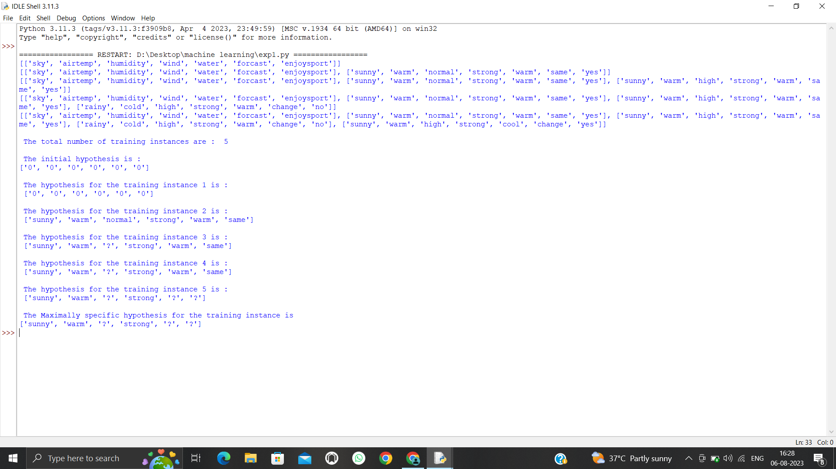2. Candidate elimination algorithm**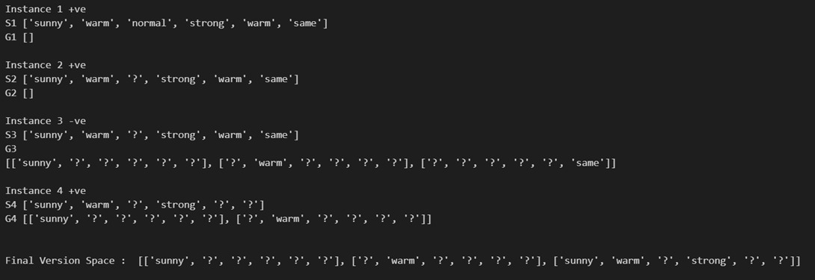

**3.id3 algorithm:**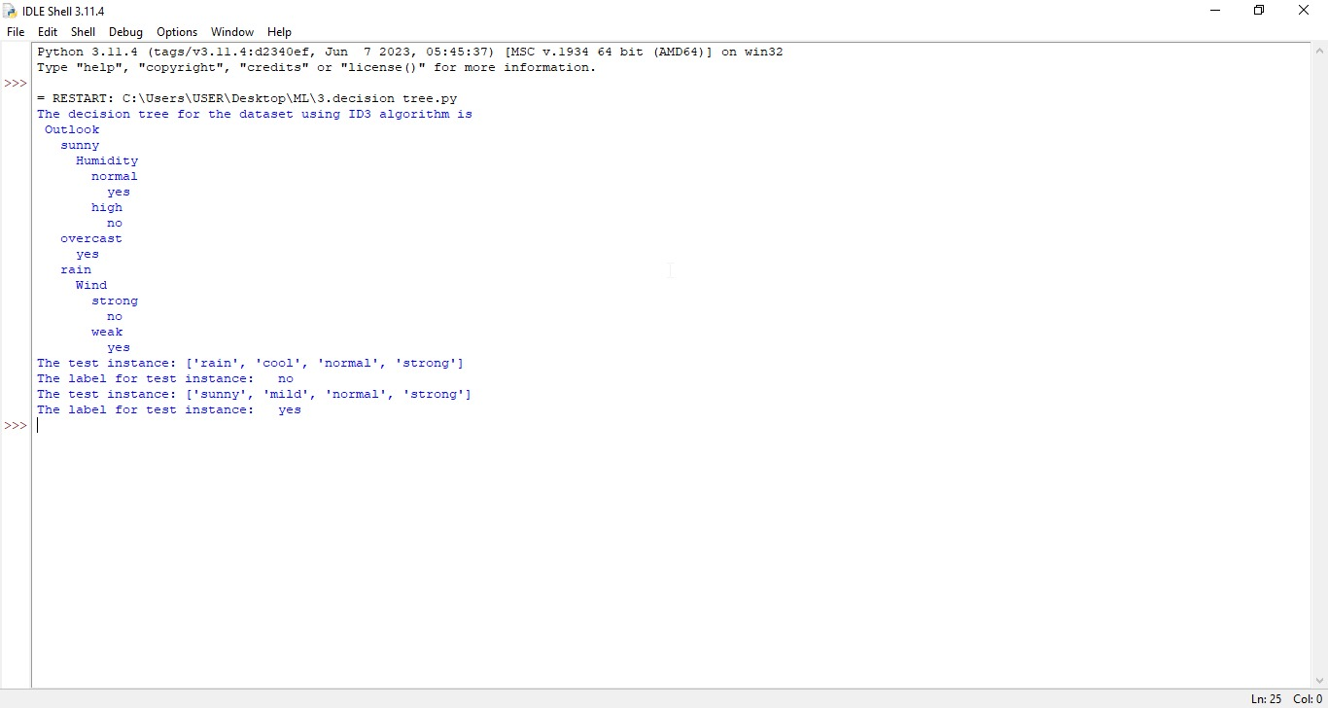

**4.back propagation algorithm**

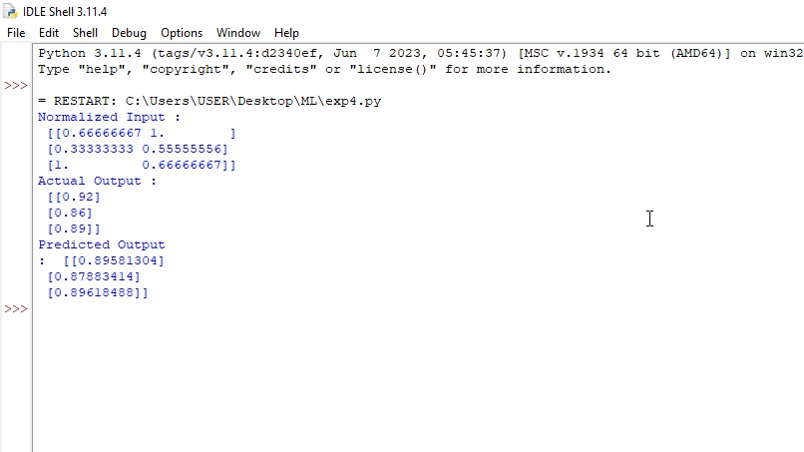

**5.** KNN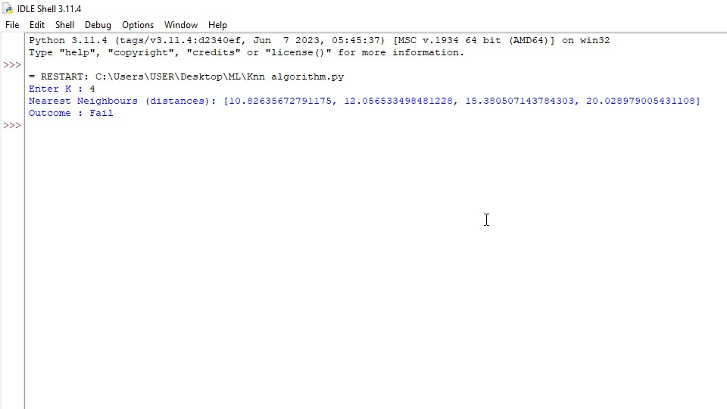**6.navie bayes algorithm:**

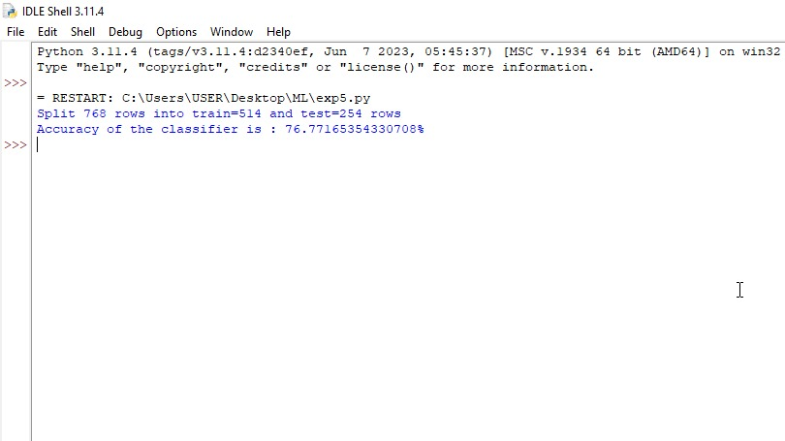

**

**8.** linear regression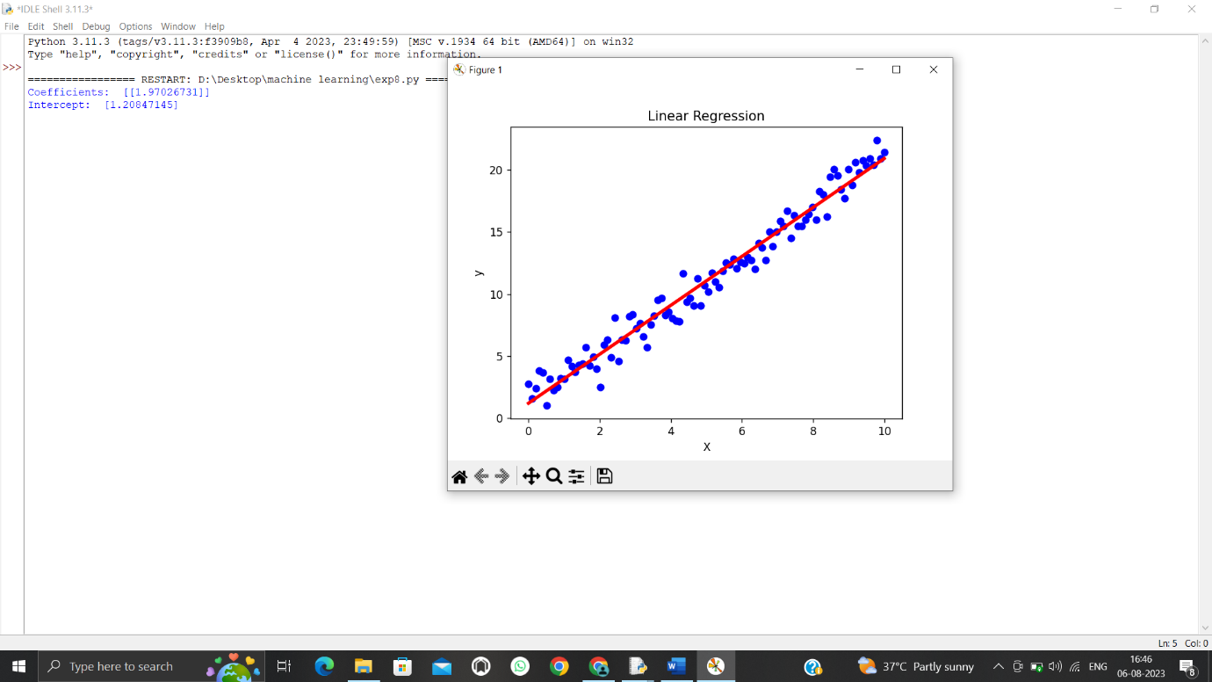

**

10.expection and maximation

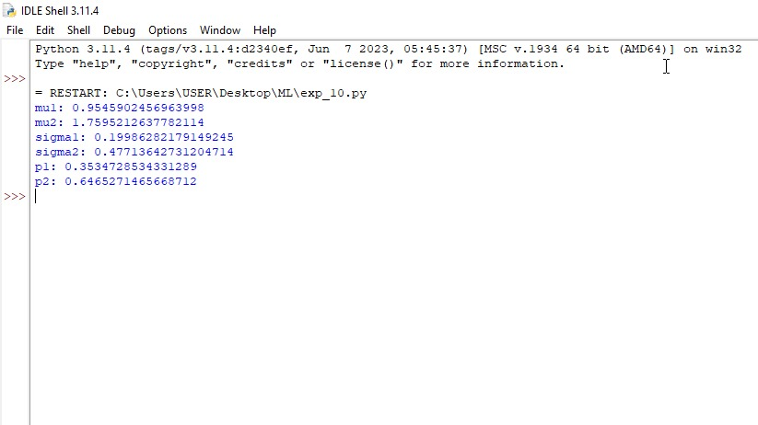

11. credict score classification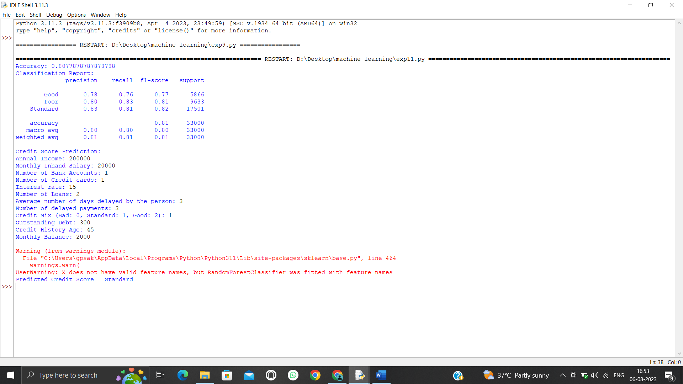

12. iris flower classification using knn

13. car price prediction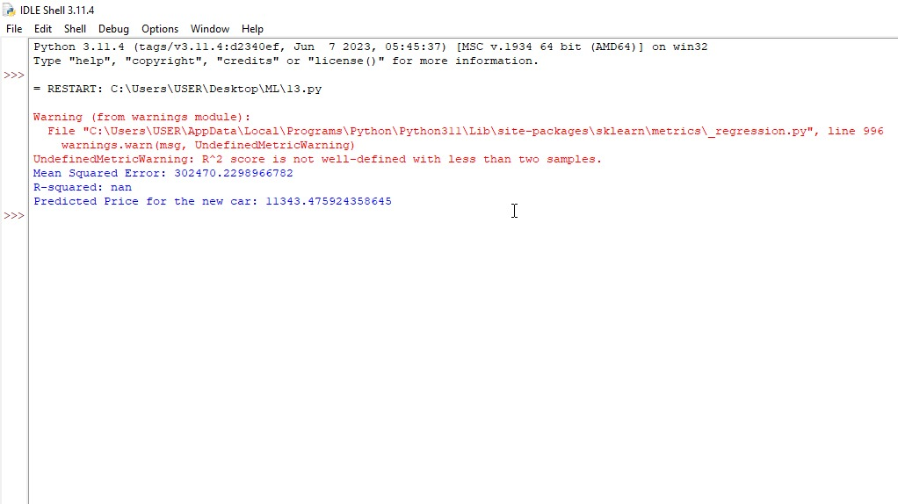

14.house price prediction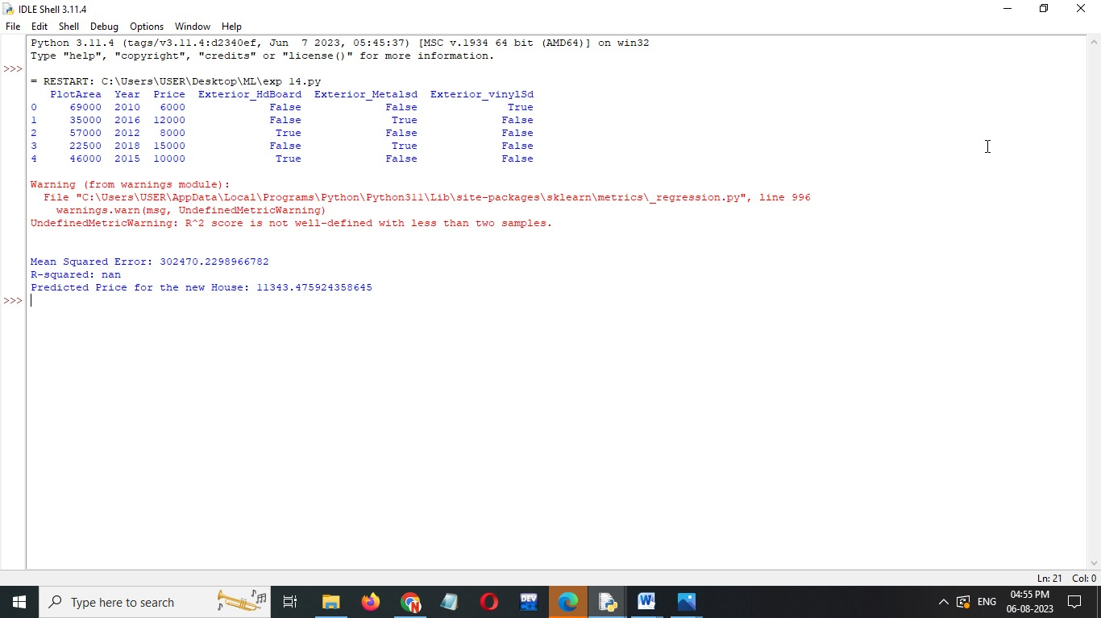

15.navie bayesiris classification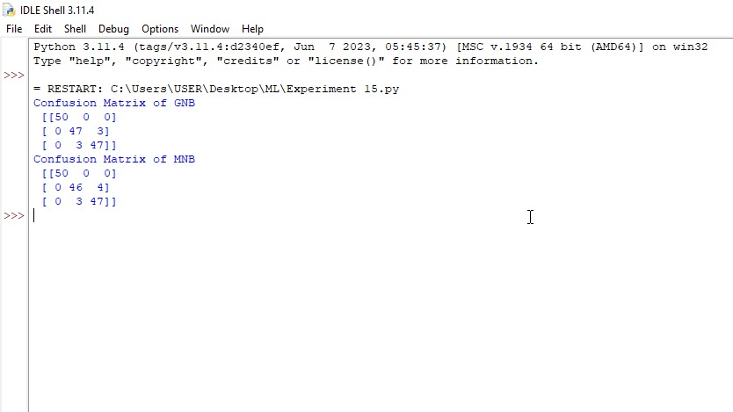

16.comprision of classification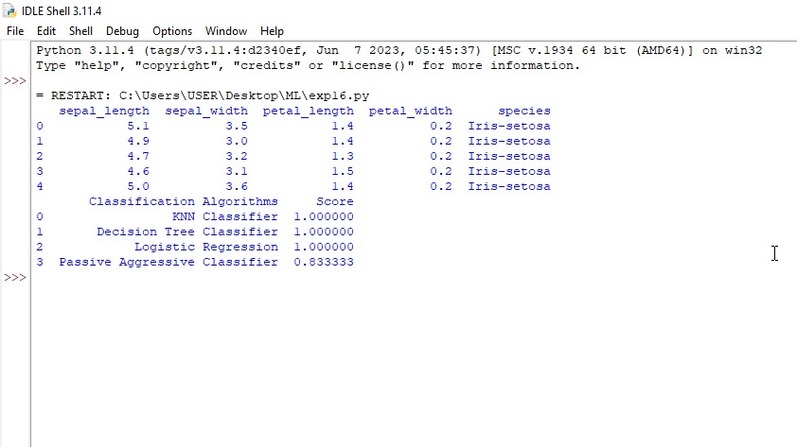

17.mobile price classification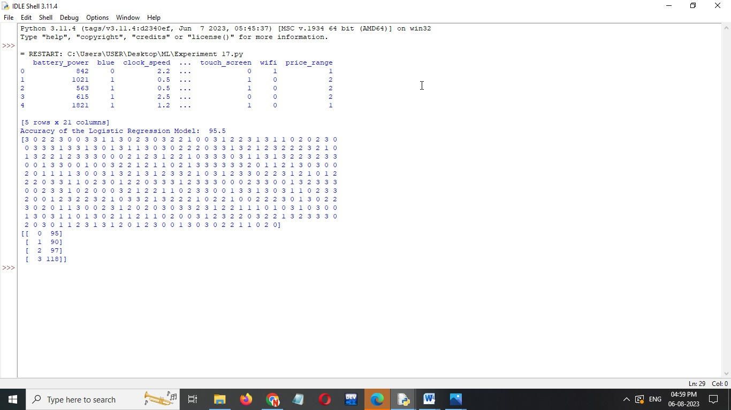

18.perception iris classification

